
Gated Community with
Spacious 1 & 2 Bedroom Homes
Single Level Style
* Fitness Center * Sauna
* In-ground Pool * Storage in Bsmnt
* Tennis Courts * Patios/ Balconies

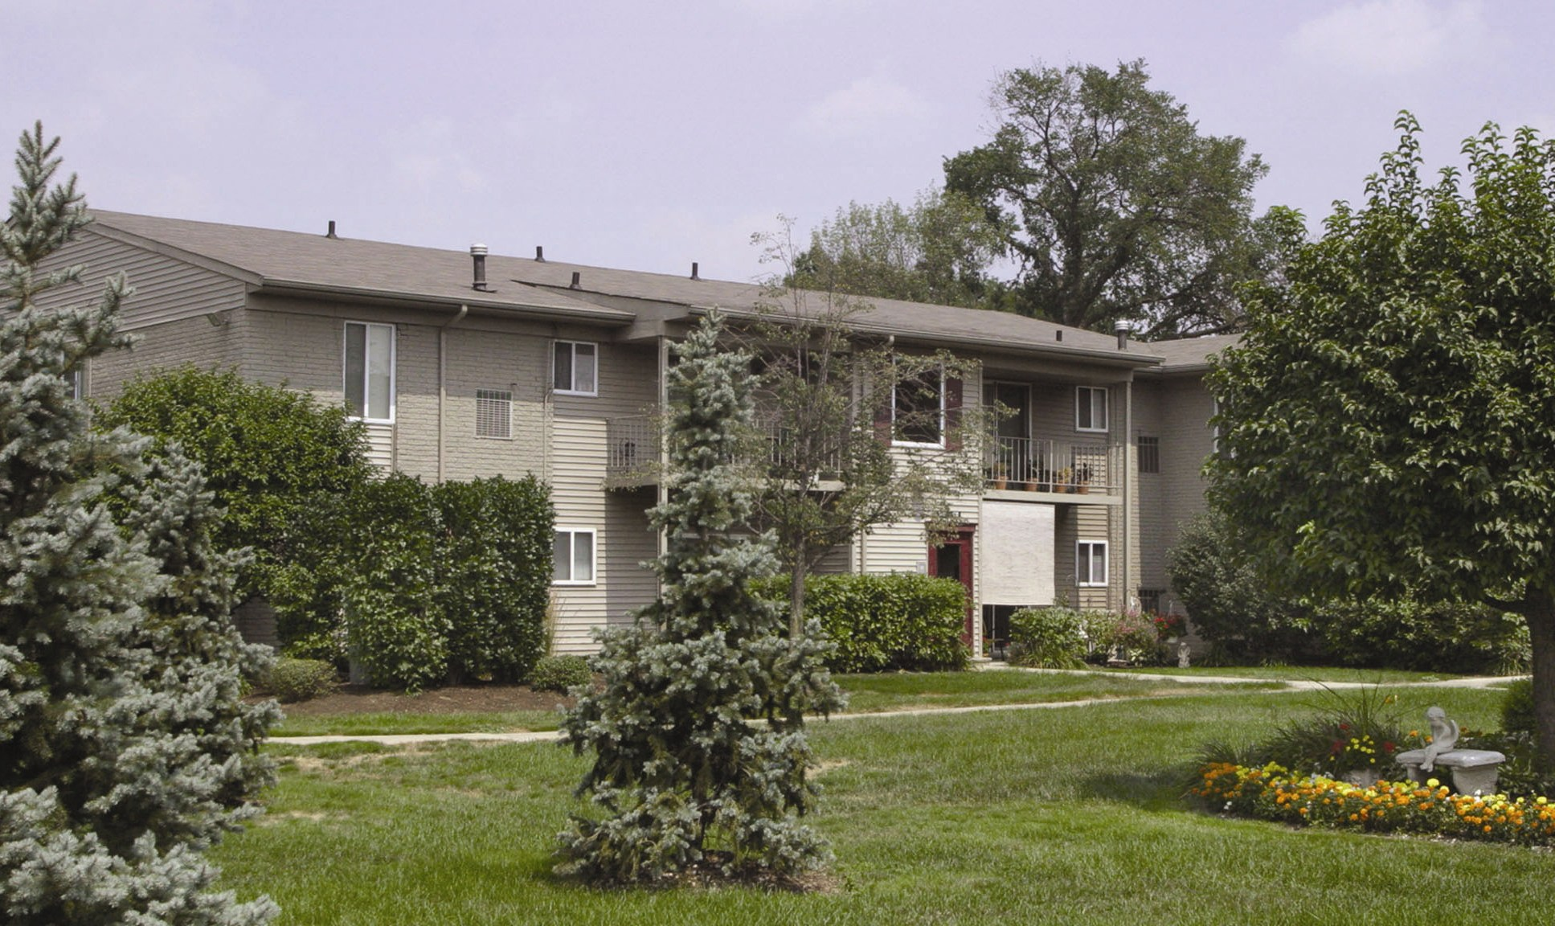

One Bedroom Units
From $550

Two Bedroom Units
From $615

Conveniently located North of I-75, east off Pelham between Goddard and Wick in Allen Park.

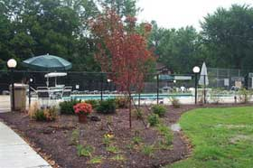
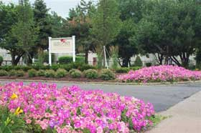

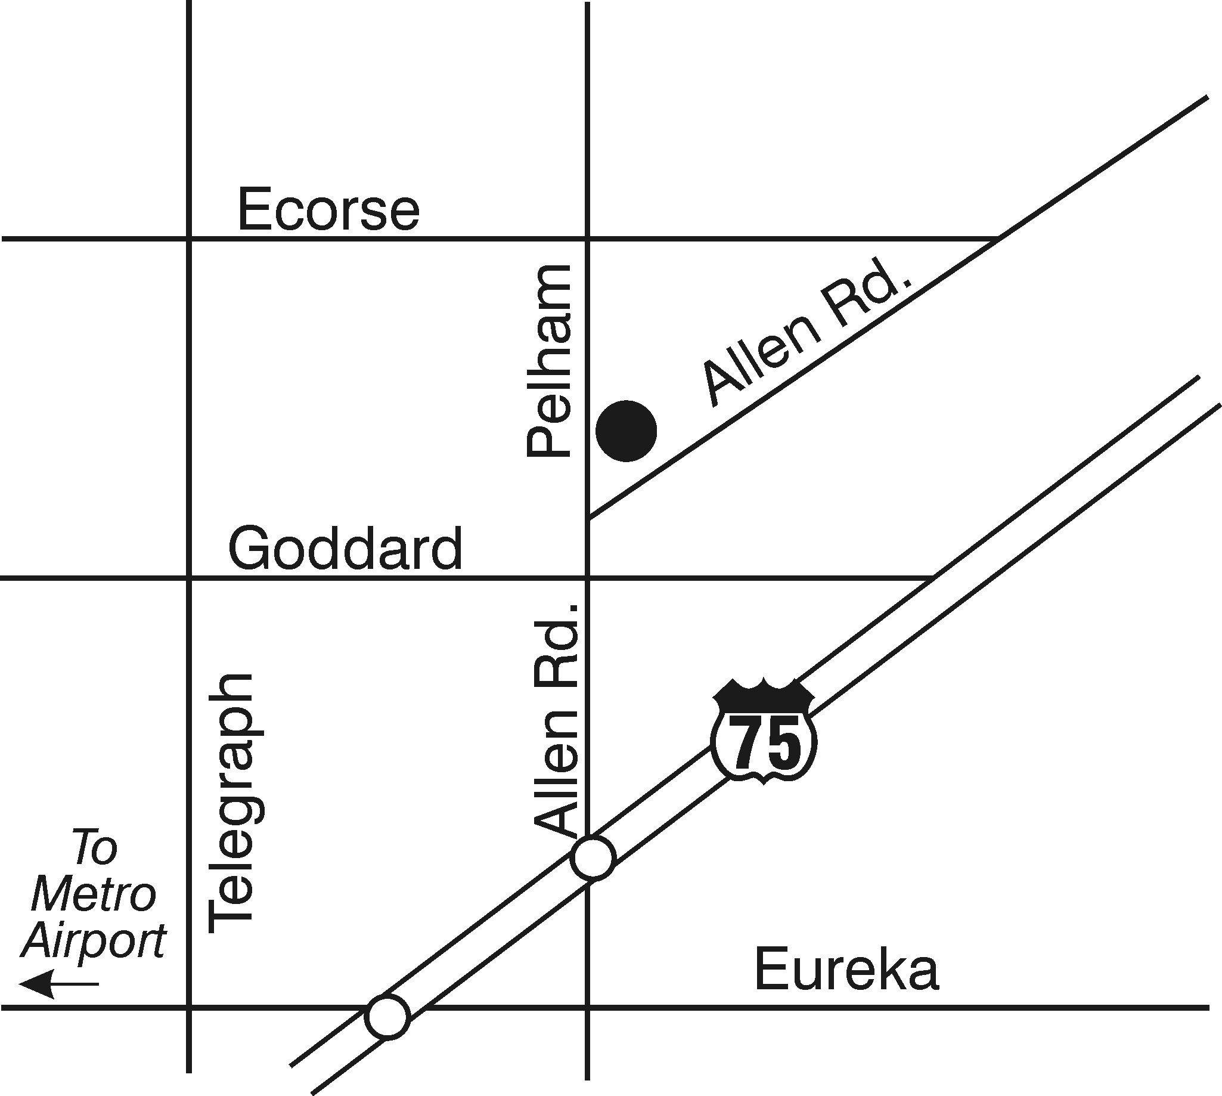


Please call for our monthly lease specials!

Open Monday through Friday 9:00 AM – 5:00 PM
10100 Allen Pointe Drive
Allen Park, Michigan 48101

248.386.3499

248.377.2200
www.brasstitan.com
248.377.2200
www.brasstitan.com

