Luxury 1 & 2 Bedroom Homes
Single Level Style
* Private Entries
* Community Clubhouse
* Fitness Center
* In-ground Pool
* Jacuzzi
* Tennis Courts

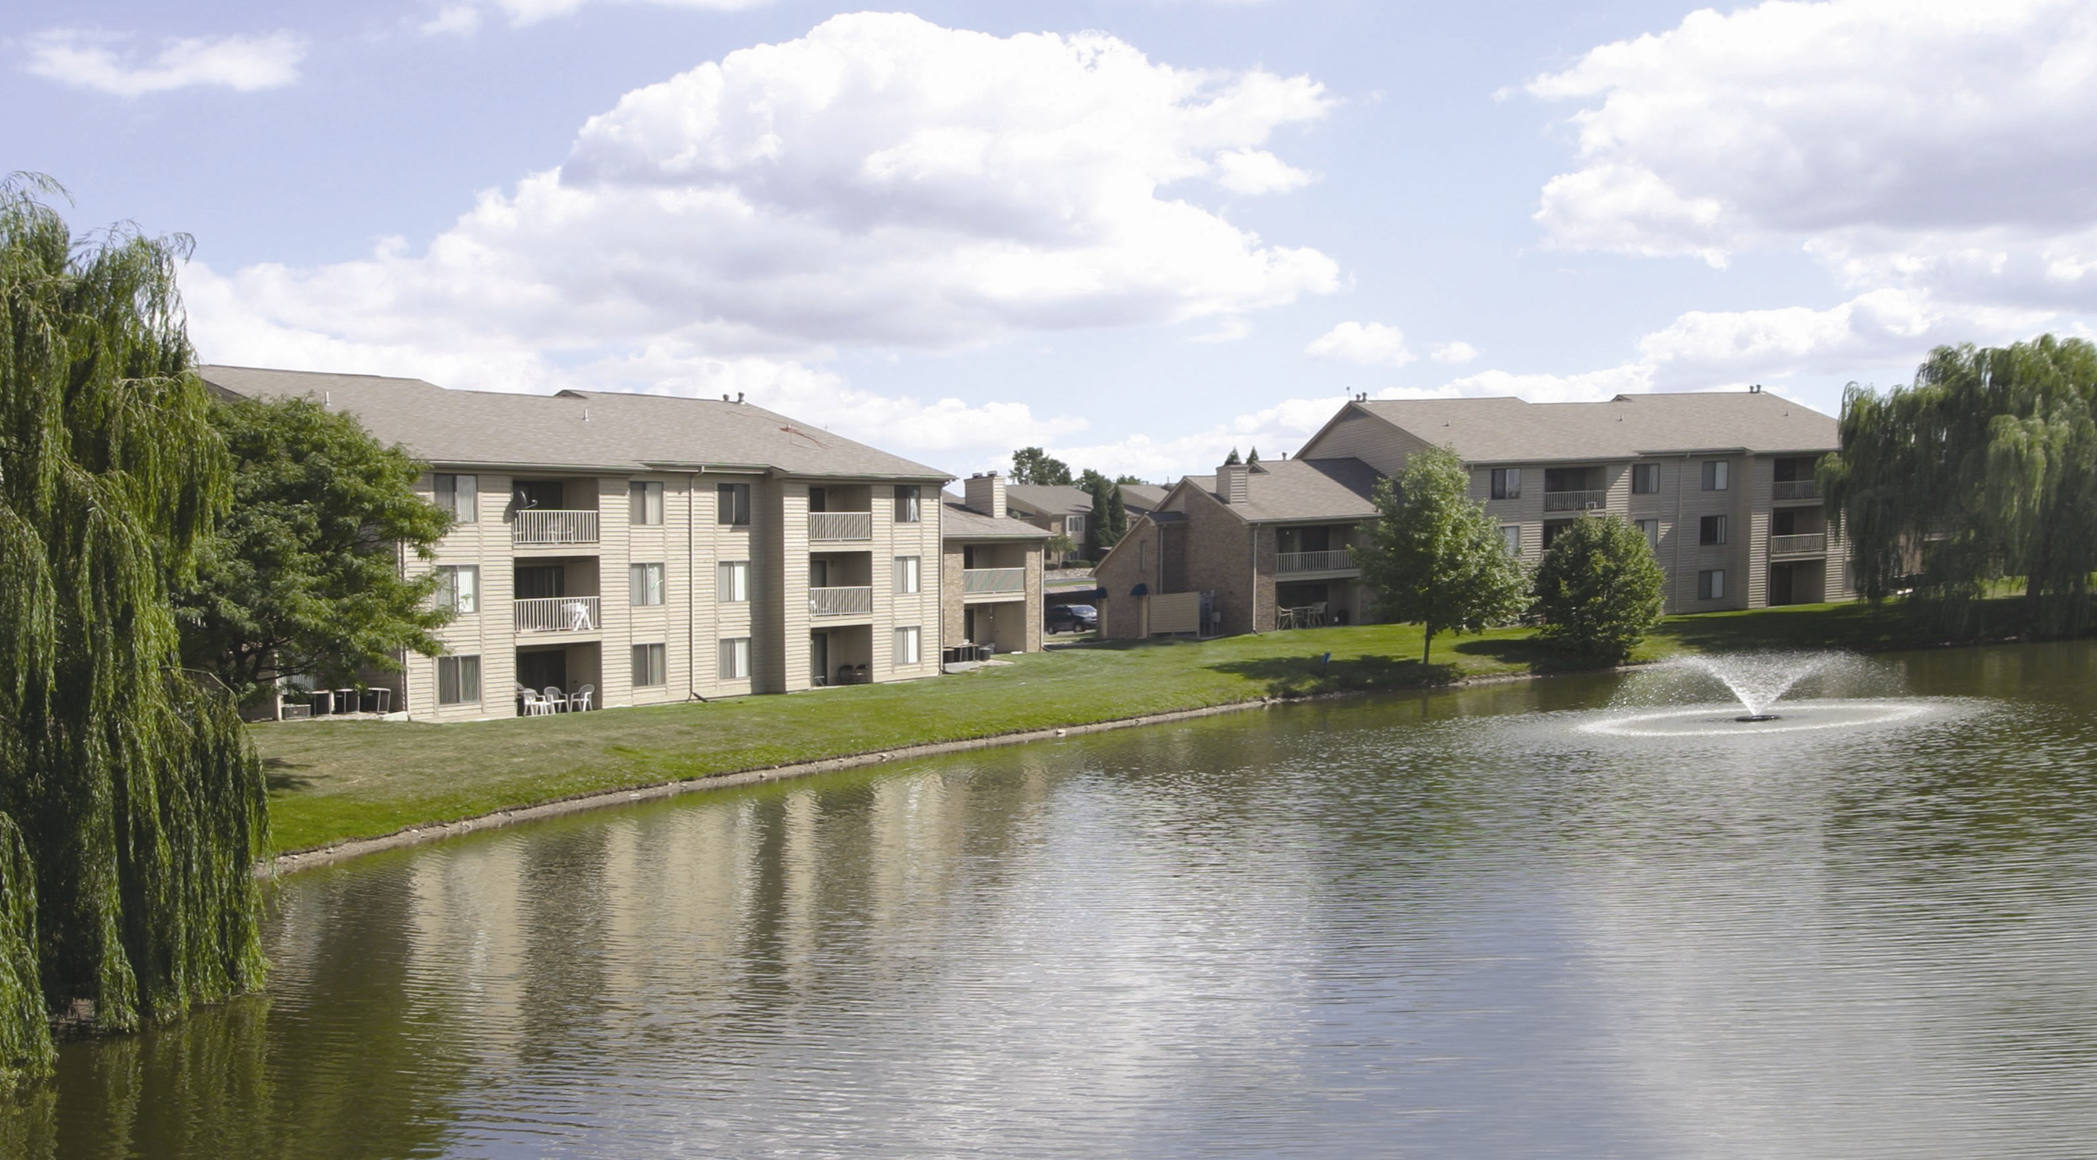

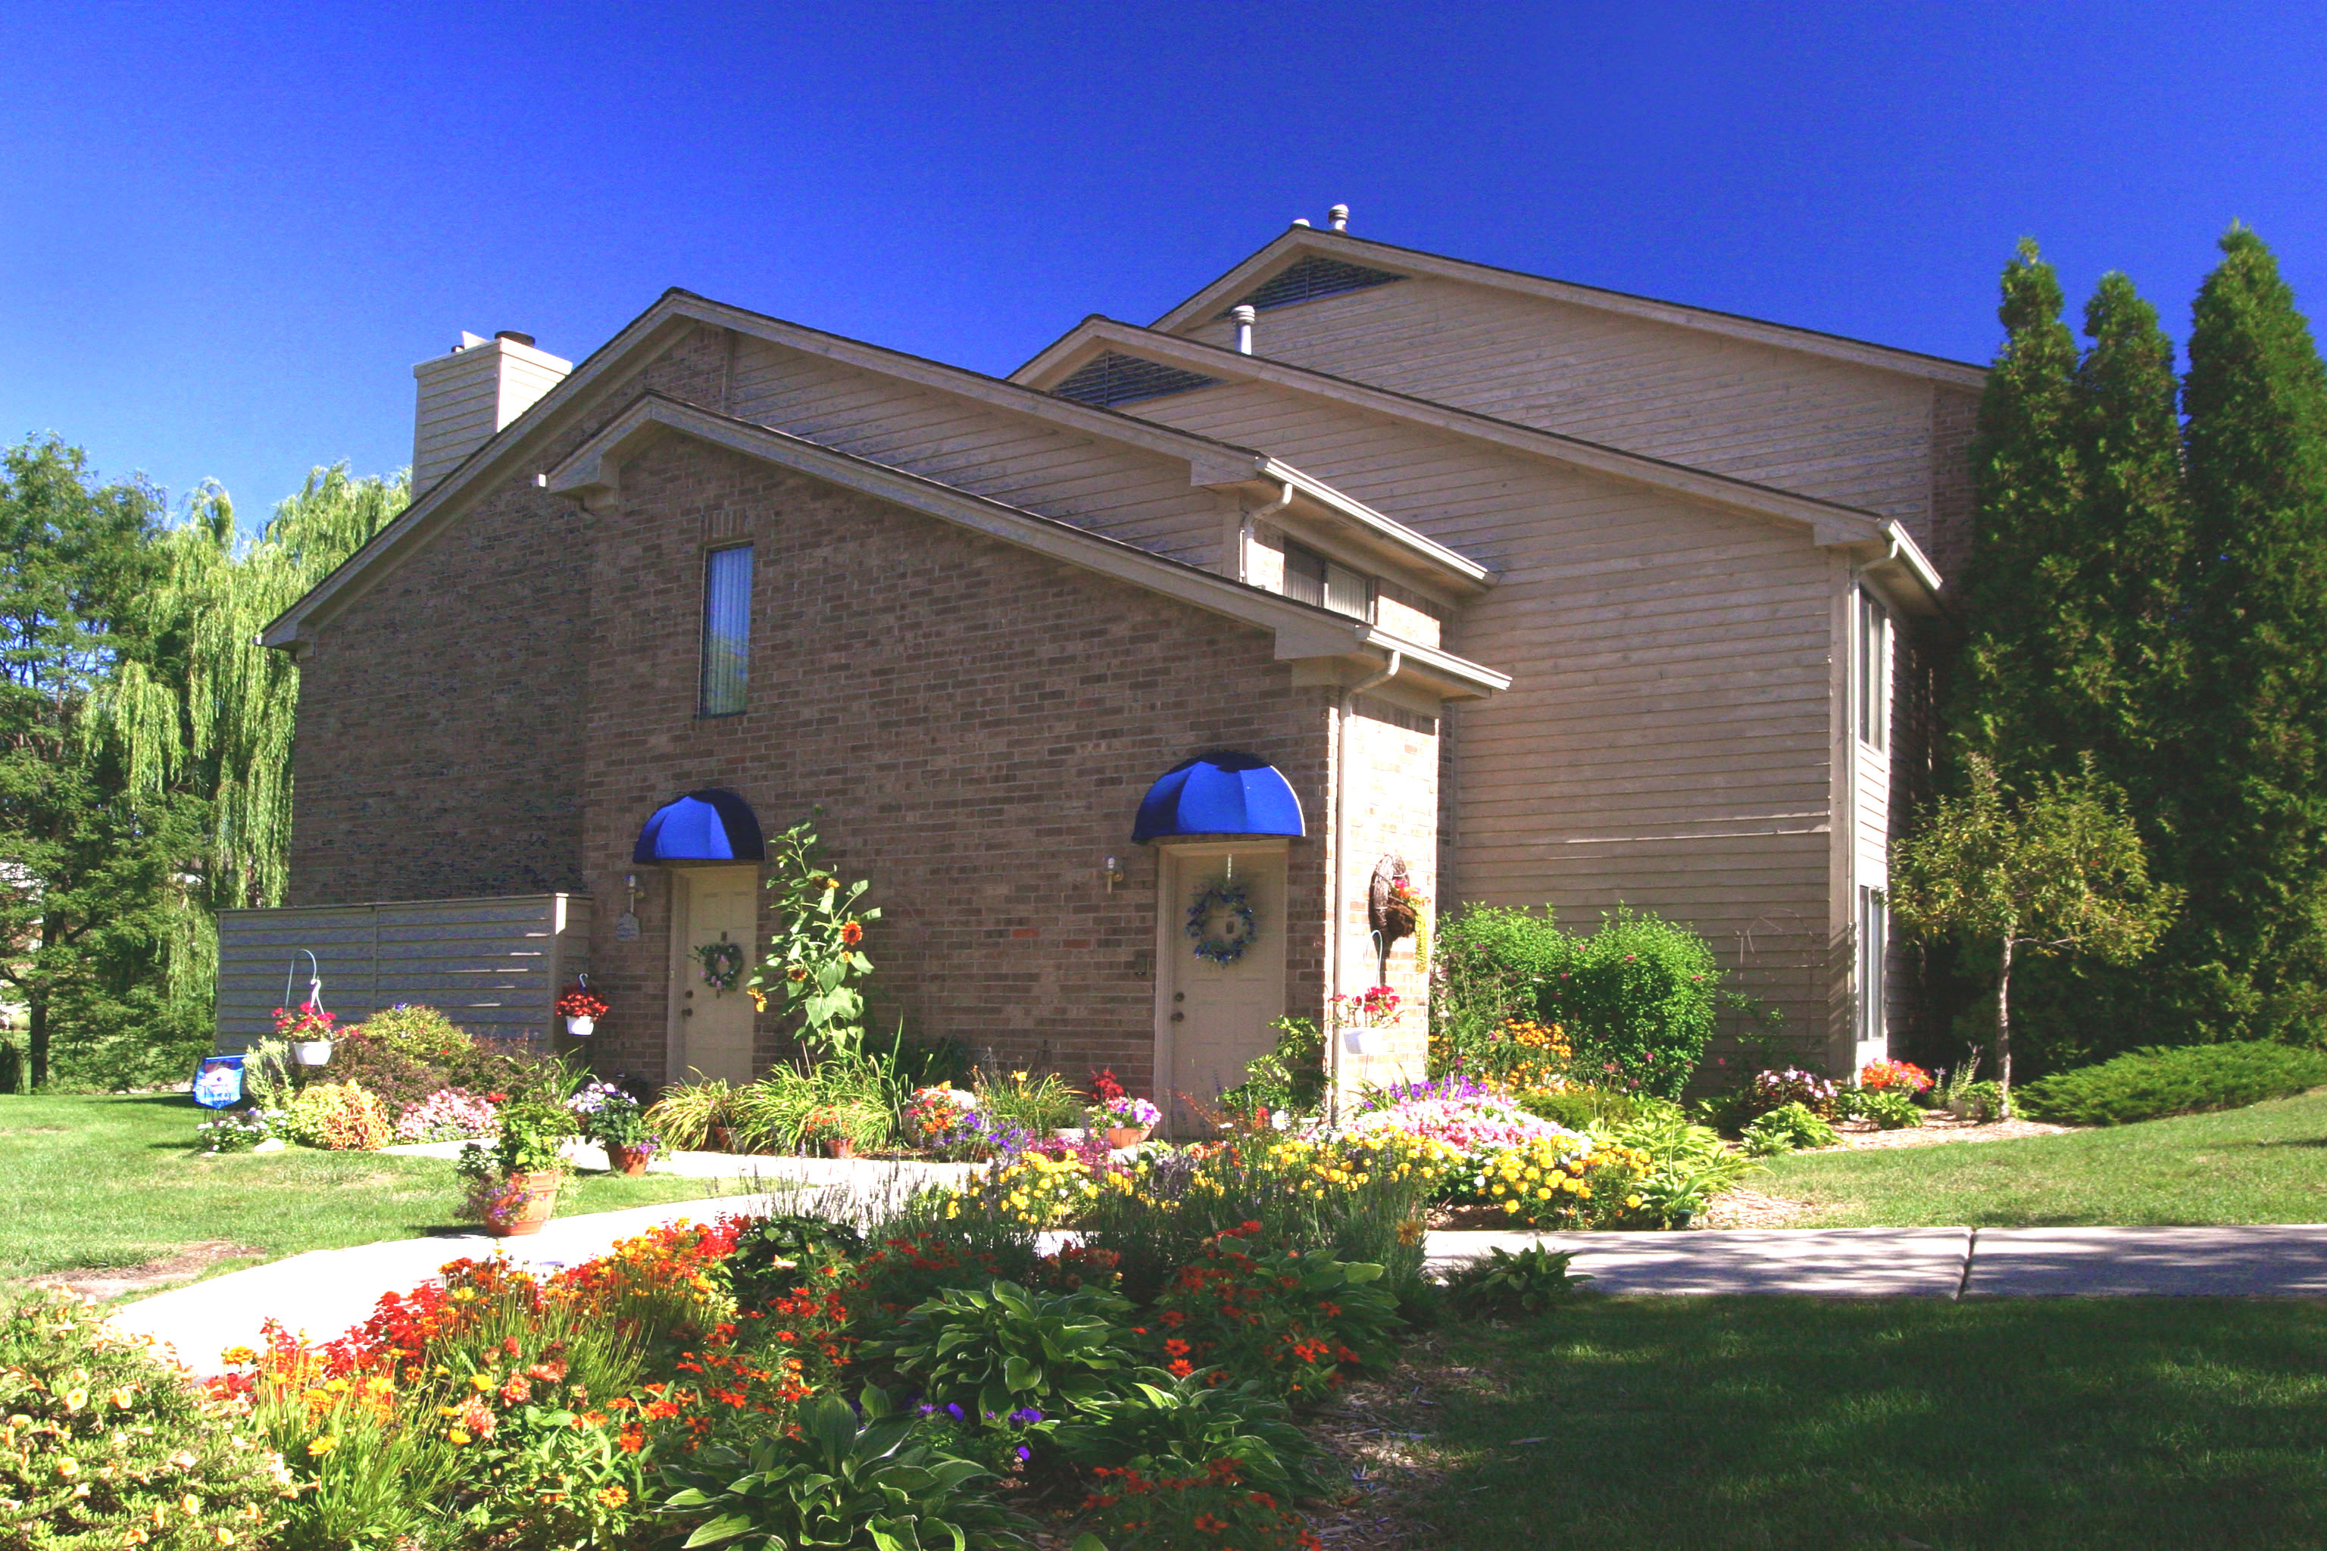

One Bedroom/ 2 Bath From $925
Two Bedrooms/ 2 Bath From $1,110
Furnished Rental Apartments From $1,650/ mo

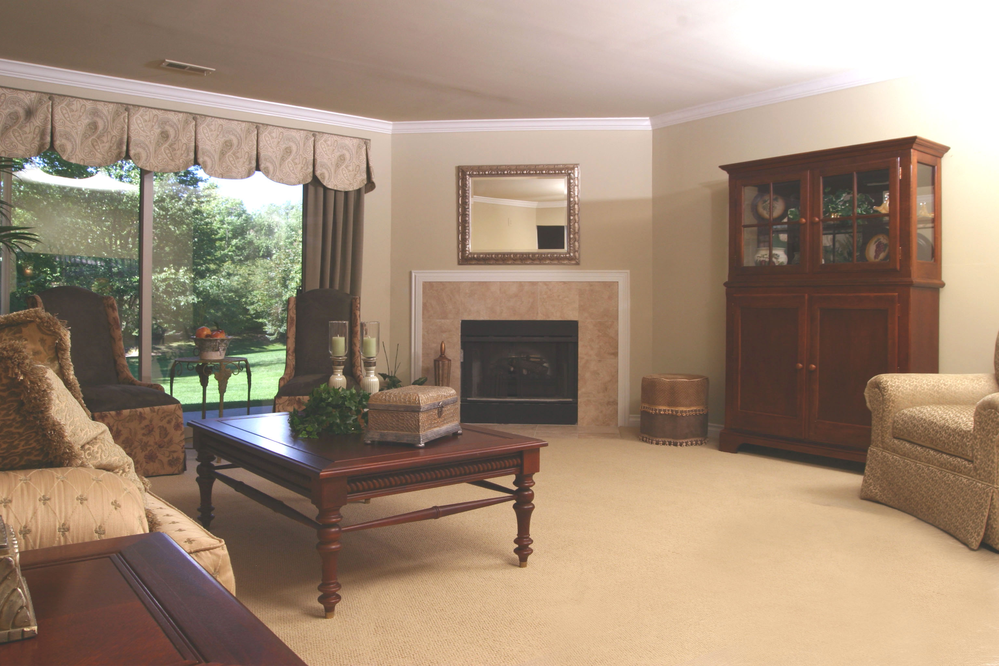

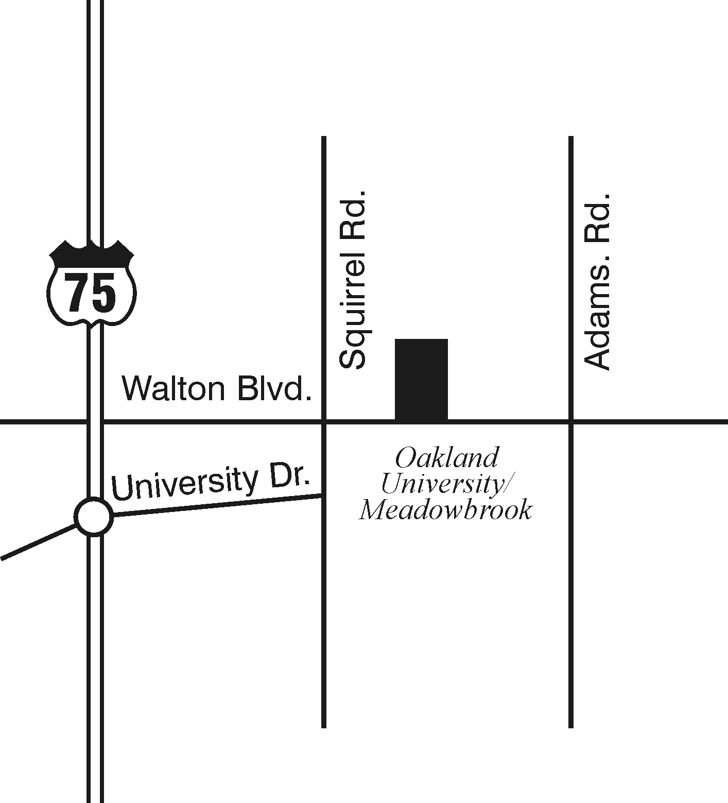

Conveniently located North of Walton Boulevard between Adams and Squirrel in Auburn Hills.


Please call for our monthly lease specials!

Open Monday through Friday 10:00 AM – 6:00 PM
Saturdays 11:00 AM – 6:00 PM
2651 Greenstone Boulevard
Auburn Hills, Michigan 48326

248.377.2200

248.377.2200
www.brasstitan.com

