
1 & 2 Bedroom Units in Great Area
Single Level Style
* Fitness Center
* In-ground Pool
* Patios/ Balconies

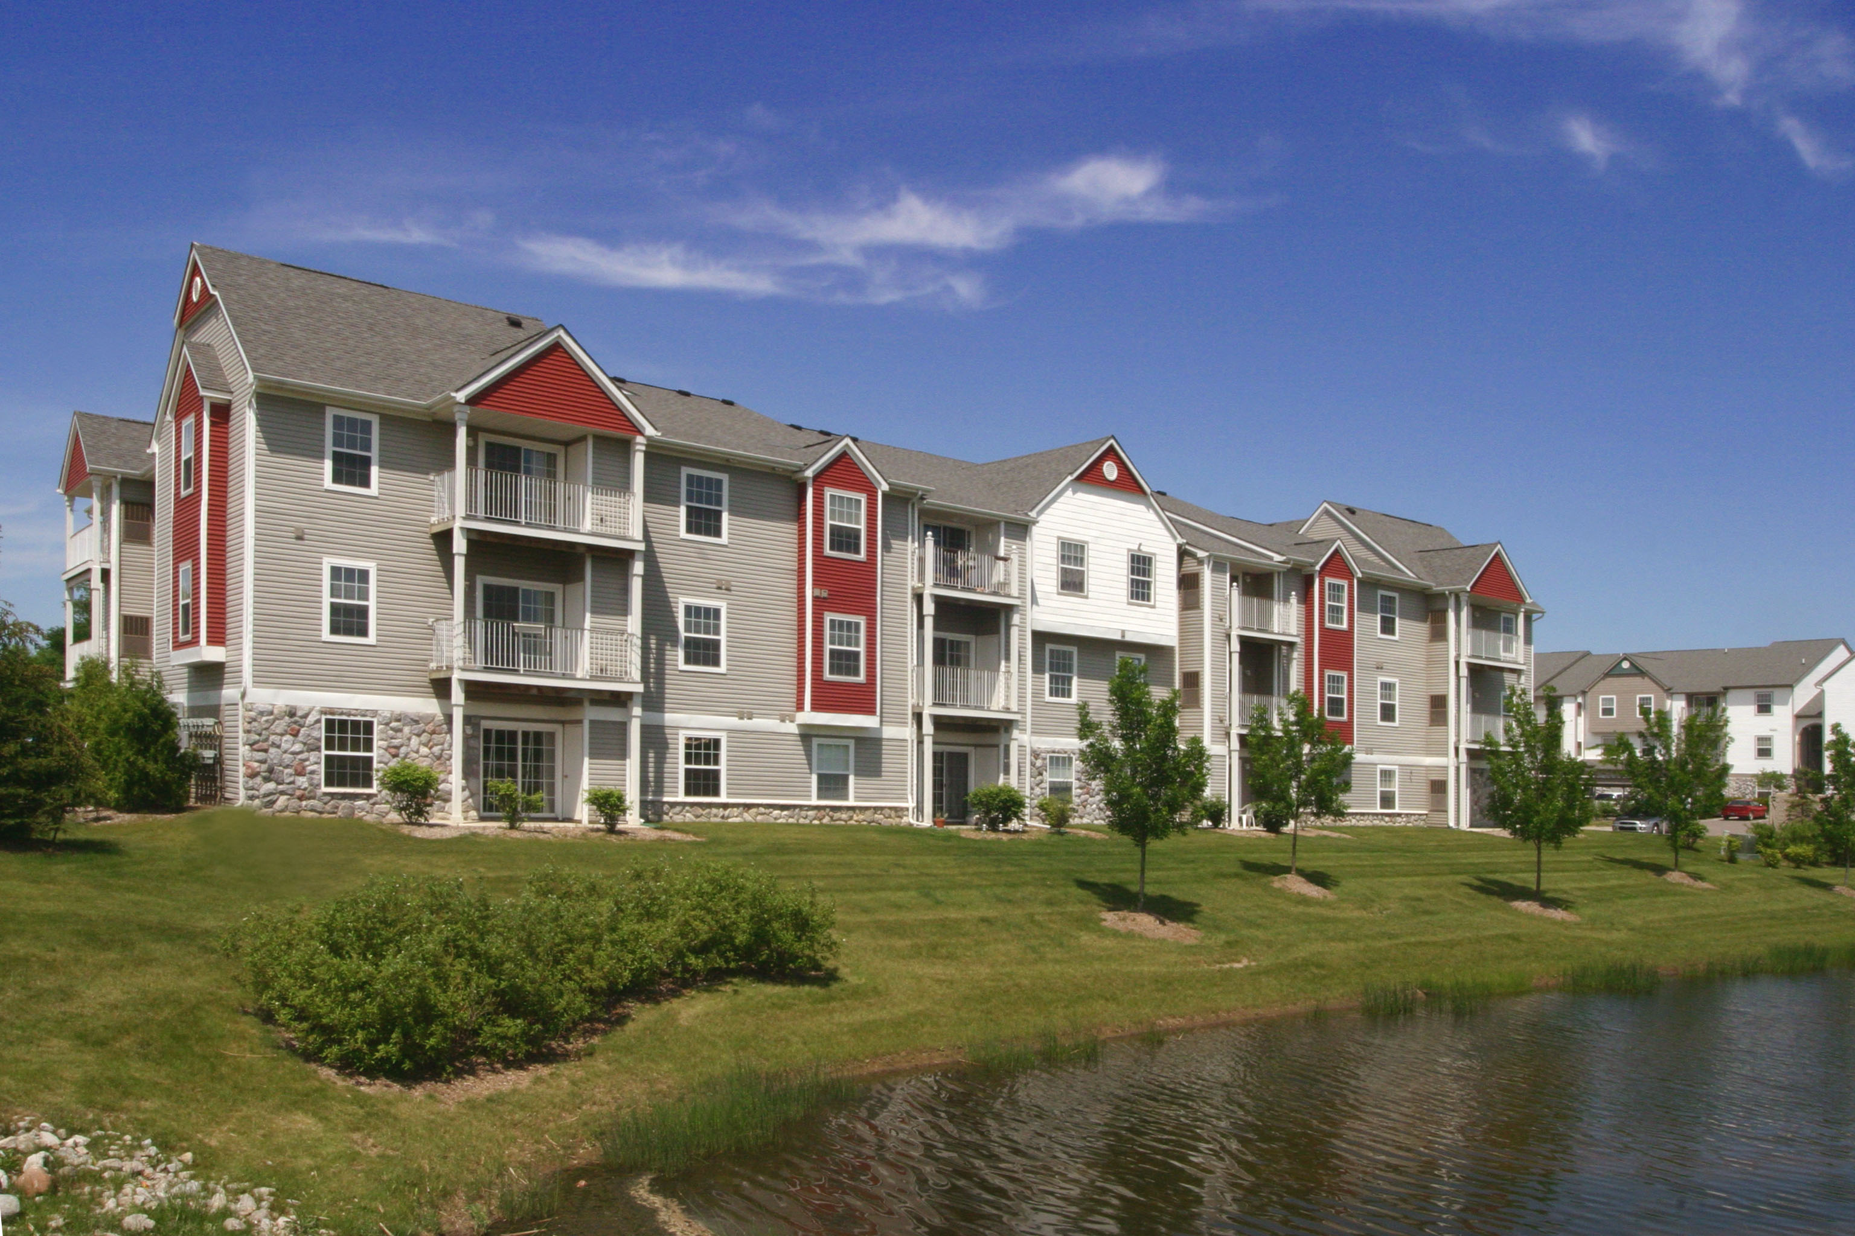
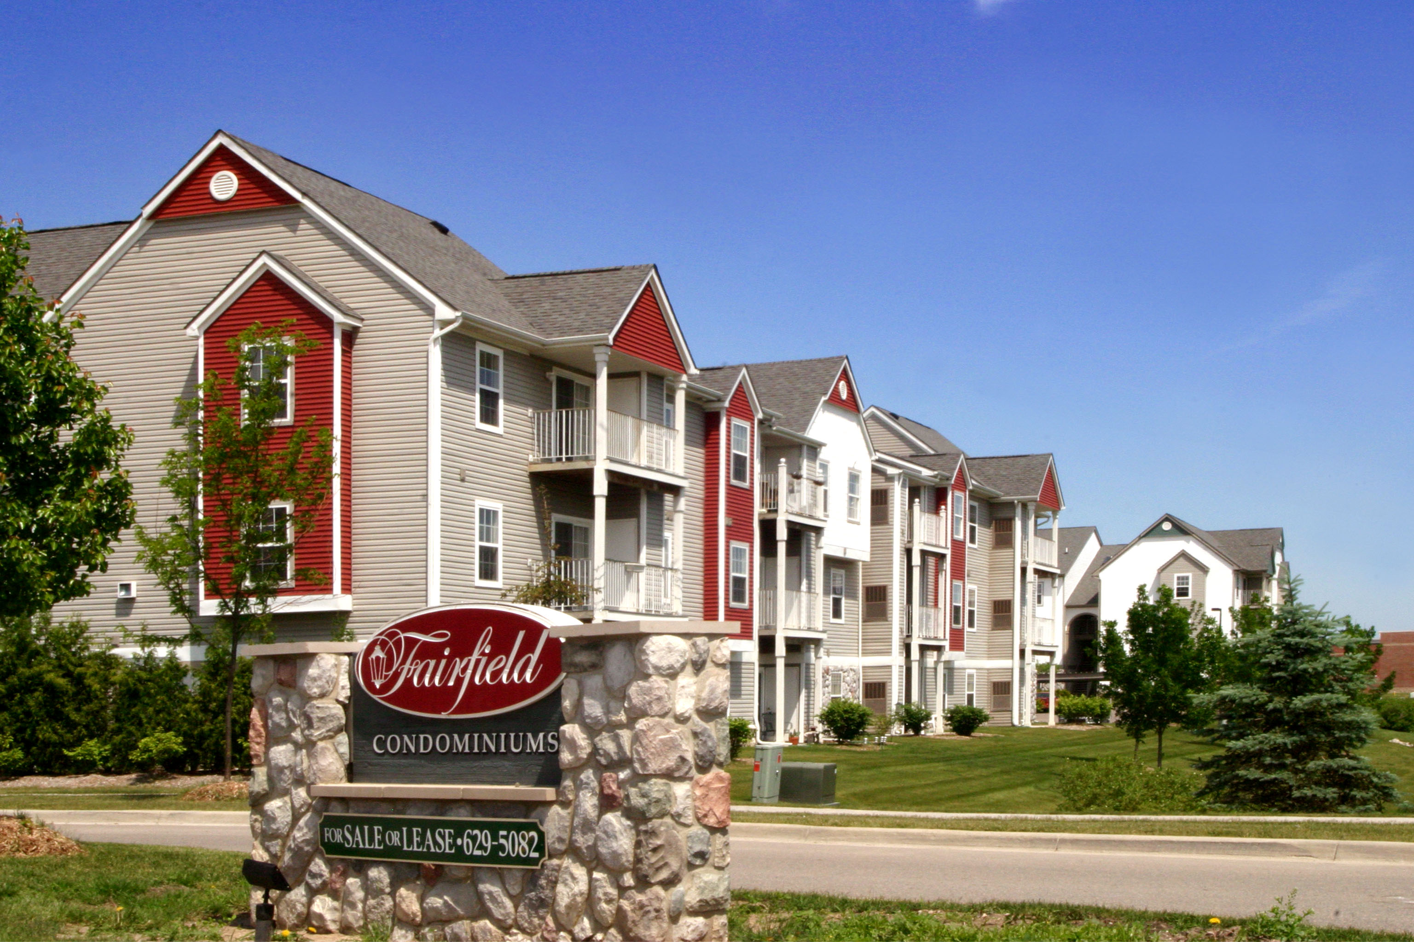

One bedroom units from $550
Two bedroom units from $615

Conveniently located West of US-23, West off Silver Parkway and South of
Silver Lake Road in Fenton.

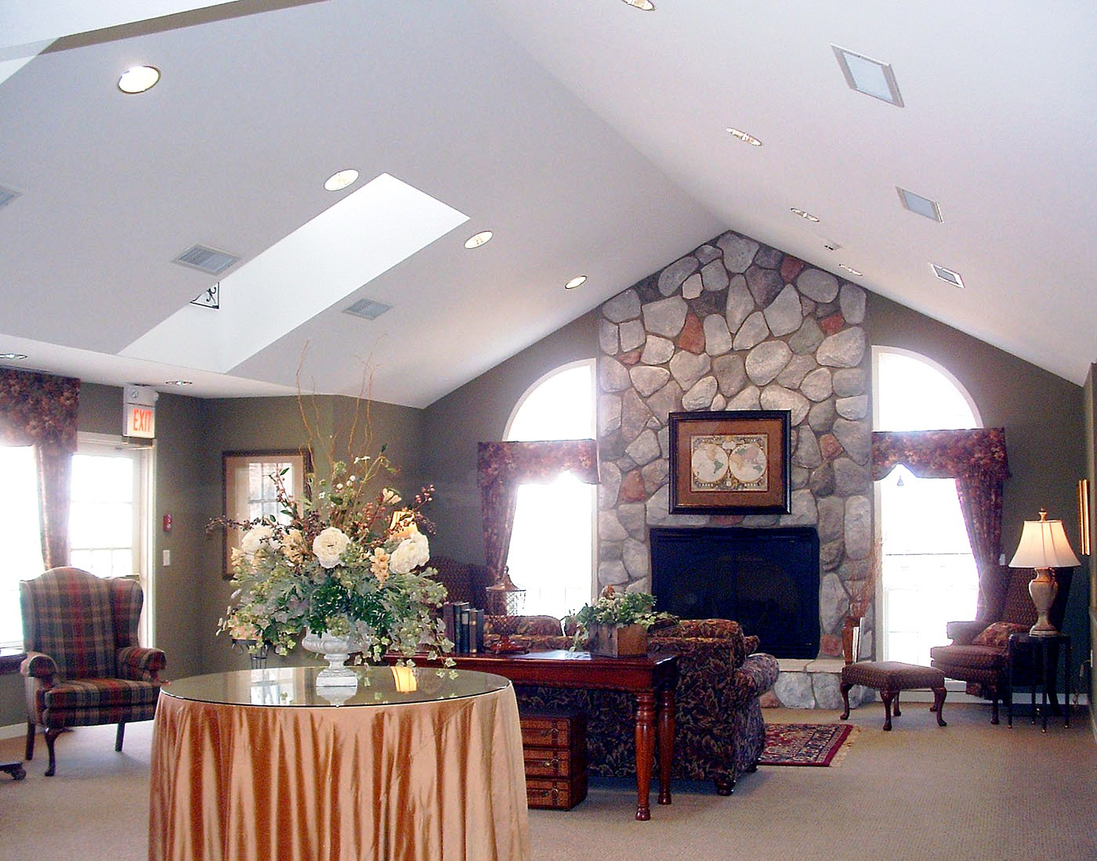
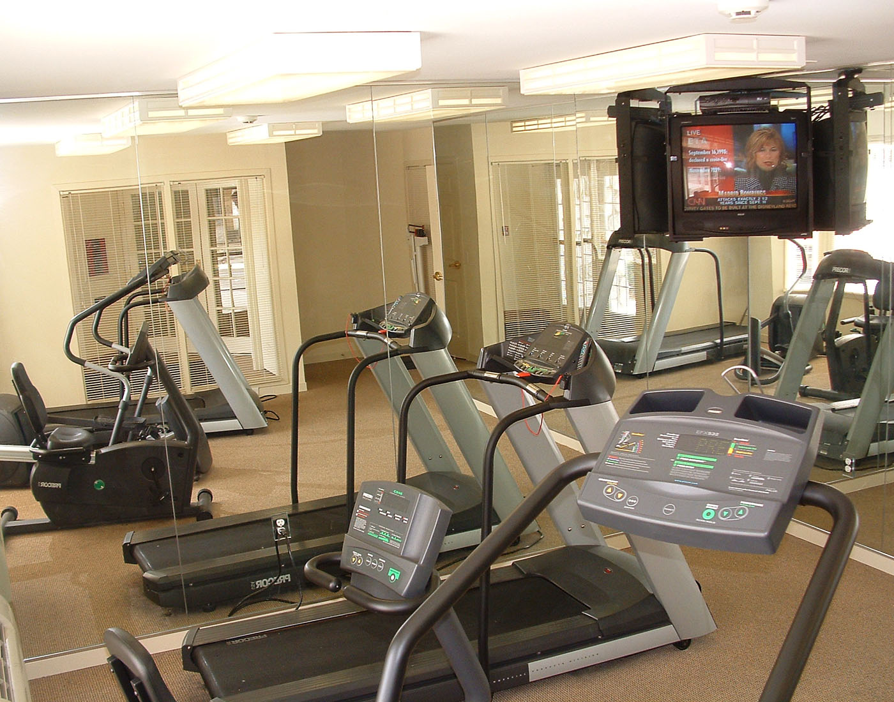


248.377.2200
www.brasstitan.com

Please call for our monthly lease specials!

Open 10:00 AM – 6:00 PM Daily
16000 Silver Parkway Drive
Fenton, Michigan 48430

810.629.5082

