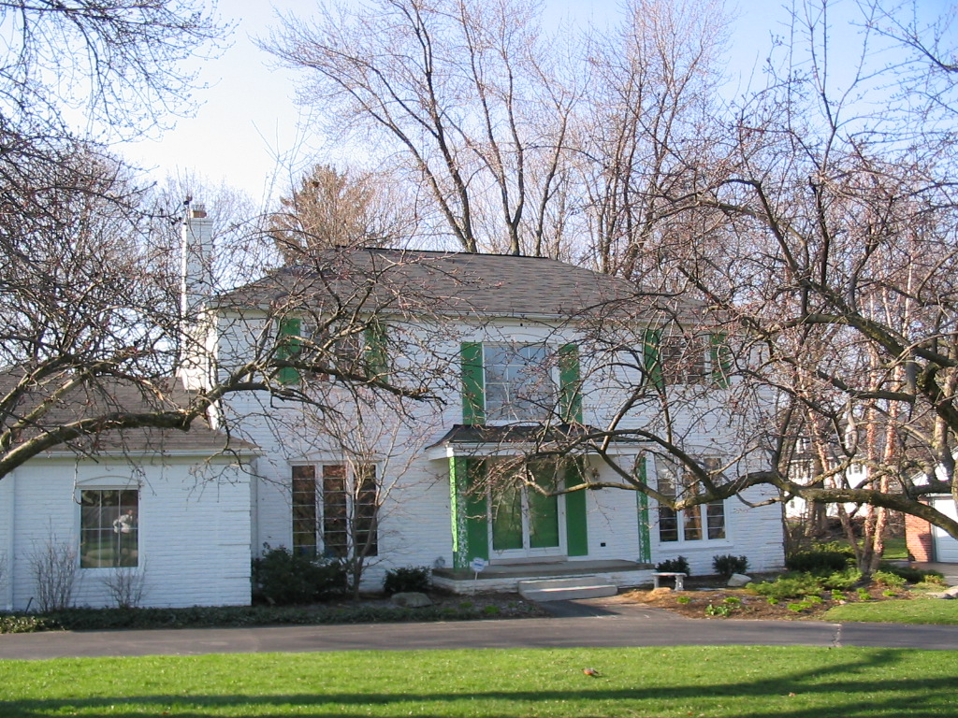
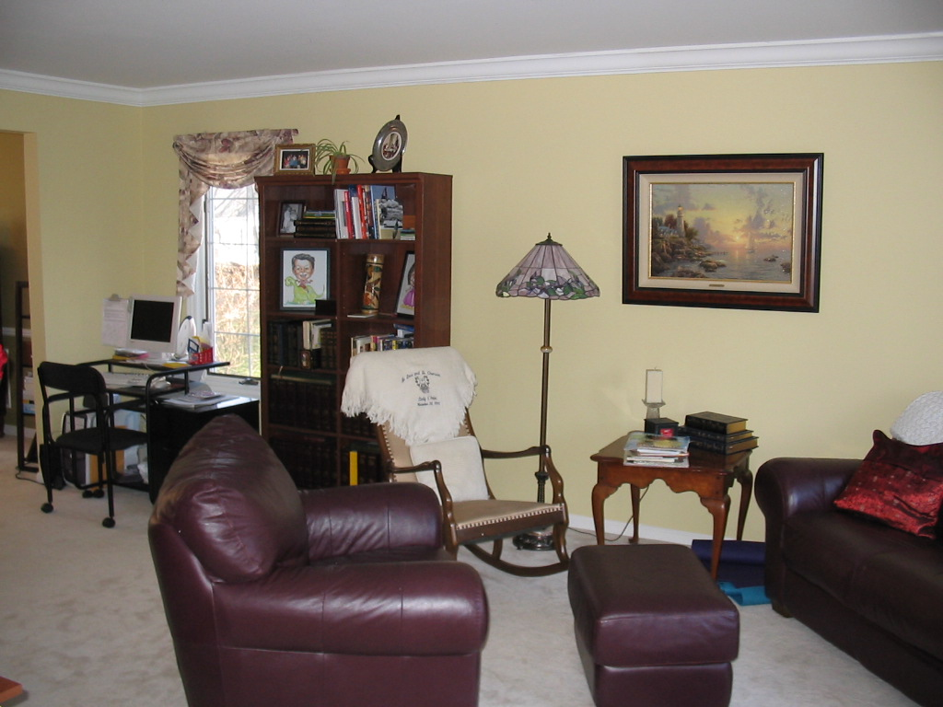
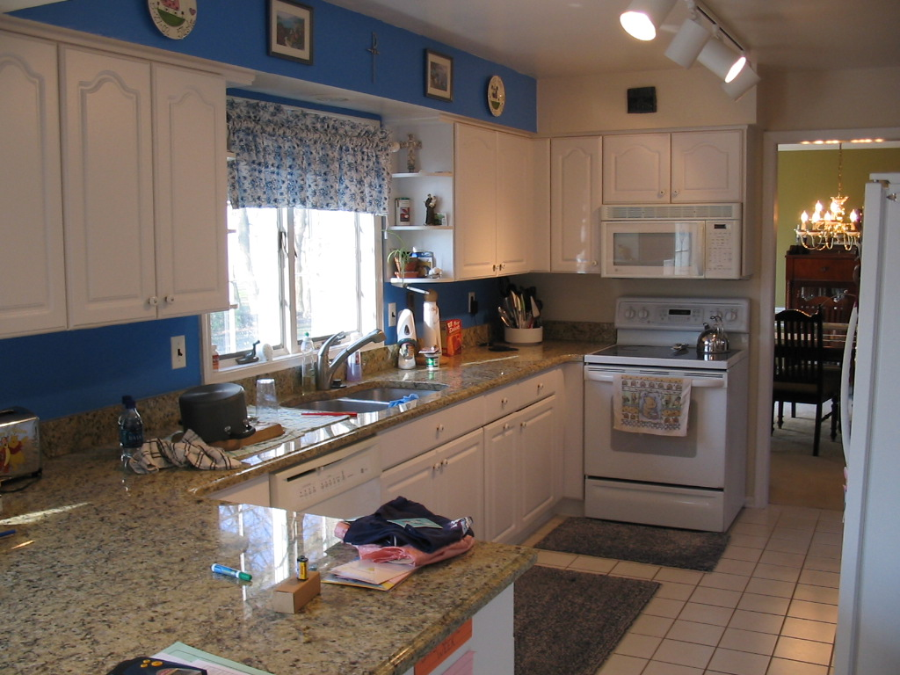
Living Room 18-9 x 13-2
Dining Room 13-2 x 12-0
Kitchen 14-9 x 7-11
Master Bedroom 13-2 x 17-7
Bedroom 2: 11-9 x 13-4
Bedroom 3: 13-7 x 11-11
Bedroom 4: 11-8 x 13-3
Family Room: 15-8 x 13-2
Breakfast Nook: 10-1 x 13-2
Laundry Room: 6-7 x 8-7

4 spacious bedrooms w/ 2.1 baths on a quiet cul-de-sac & corner lot. Birmingham Schools w/ walking distance to Harlan Elem. New granite in kitchen & baths, hardwood floors in Family Room & most of 2nd floor, ceramic tile in full baths w/ marble in foyer and half bath. 2 door walls lead to brick paver patio & large backyard. Perfect family home! Seller is a licensed agent.
.

Exclusive Listing by Brass Titan, LLC

978 Adams Castle Drive

Bloomfield Township, Michigan 48304

For more information, please contact:

Peter C. Cubba
Associate Broker

Office: (248) 377-2200
Cell: (586) 634-3226
Features
- Birmingham Schools
- 4 Bedroom / 2.5 Full Bath Colonial
- 2,800 square feet
- Eating space in Kitchen
- 1ST floor laundry
- Built in 1968
- Lot Size: 116’ x 139’
- 3-car attached garage
- Estimated taxes (based on 2006): $6,880

Located: North of Big Beaver, West off Adams
Legal Description: T2n, R10e, Sec 24 Adams Castle Lot 5, PID: 1924429023

Room Sizes

SALE PRICE: $489,900
- Full basement
- Wood/ Brick Exterior
- Gas Forced Air Heat
- Gas Hot Water
- Central Air

Specifications

